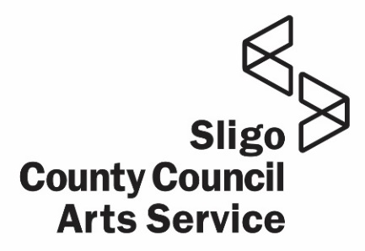


Culture Night is brought to you by Sligo County Council Arts Service Department in partnership with The Arts Council

Event Organiser Name:
Address:
Email:
Tel:
Would you like to be added to Sligo Arts Service new Mailing List & receive updates from us? Yes No
You can only apply under 1 funding strand; please indicate which Strand you are seeking funding under:
FLAGSHIP EVENT (Up to €2,500)
FEATURED EVENT (Up to €1,000)
CULTURE WIDE PROGRAMME (Up to €700)

Event Title/Name:

Is this event being specifically developed/presented for Culture Night?
Proposed location of Event:
If this is an outdoor event who owns the site & has permission been sought to use it?

Proposed Time of Event:
Who is the Target Audience:
Estimated attendance / capacity:

Brief outline of Proposed Event (attach detailed description as part of supporting documentation):
BUDGET TEMPLATE
If you are applying for a FLAGSHIP Event, please attach a detailed breakdown of fees for artists, creatives, technical etc. Flagship applicants should also supply details where relevant of staging and technical costs
EXPENDITURE Item | €
Artist Fees *
Other Creative Fees: Producers / Curators *
Technical Fees: Sound & Lighting Engineers / Stage Managers / Install Crew /*
Technical Costs: Sound / Light / Projection
Other Staging Costs
Accessibility Costs
Transport Costs
Security (Outdoor events)
Workshop Material Costs
Venue Hire
Venue Set-up
Insurance
Staffing costs
Travel & Accommodation
Hospitality
Other: Please specify
TOTAL EXPENDITURE:
INCOME Item | €
Amount Requested from Culture Night Fund
Other Funding: Please specify below
TOTAL INCOME:
Surplus/Deficit:

If a deficit exists, please indicate how this will be met:

Any other relevant information which may support your application?

Signed: Date:
A single PDF that included Application form & any Supporting Documents should be submitted before Monday June 16th 2025, to artsoffice@sligococo.ie

